**Total POINTS 100**

**TRUE/FALSE QUESTIONs – 1pt each**

1. Shared memory IPC comes with built-in (kernel provided) synchronization **False**
2. FIFOs persist without any processes connected to them **True**
3. Shared memory and memory mapped files require 3 times the memory overhead compared to FIFO and MQ **False**
4. Pipes are supported by a First-In-First-Out bounded buffer given by the Kernel **True**
5. POSIX message queues support separate priority levels for the messages **True**
6. In POSIX message queues, the order of the messages is always FIFO without any exception **False**
7. A unnamed pipe can be established only between processes in the same family tree **True**
8. A unnamed pipe does not exist without processes connected to both ends **True**
9. In POSIX message queue, you can configure message size and number of messages between the 2 **True** processes
10. In shared memory IPC, the Virtual Memory manager maps the same piece of physical memory to the address space of each sharing process **True**
11. After creating a shared memory segment with shm_open() function, the default size of the segment is 0 **True**
12. POSIX IPC objects (message queues, shared memory, semaphores) can be found under**/dev/mqueue** and **/dev/shm** directories **True**
13. You can set/change the length of the shared memory segment using **ftruncate()** function **True**
14. In POSIX, names for message queue, shared memory and kernel semaphores must start with a "/" **True**
15. **sem_unlink()** function permanently removes a semaphore from the kernel **True**
16. You must use **ftruncate()** before using a shared memory segment **True**
17. You must call **mmap()** before using (i.e., read/write) a shared memory segment **True**

**File SYSTEMS**

1. [20 pts] Assume that a file system has each disk block of size 4KB and each block pointer of 4 bytes. In addition, the each inode in this system has 14 direct pointers, 2 single indirect pointers, 1 double indirect and 1 triple indirect pointer. Ignoring the space for inode, answer the following questions for this file system:
2. What is the maximum possible file size?

14*4kB + 2*1024*4kB + 1*1024*1024*4kB + 1*1024*1024*1024*4kB = 4.004TB

1. How much overhead (amount of non-data information) for the maximum file size derived in (a)?

There are 4.004GB worth of pointers. 4.004TB / 1024 = 4.004GB.

1. How much overhead for a file of size 6GB?

(4 * 1024 + 4kB * 1.5 * 1024 * 1024) = 6.004MB

**SIGNALS**

1. [13 pts] The following code will create a Zombie child process because the child process is terminated and the parent process is busy in a loop without calling wait() function. Now, modify this program by handling SIGCHLD signal so that no Zombie process is created. The parent process cannot call wait()directly in the main(). However, calling wait() from inside the signal handler is fine. The main still must go to the infinite while loop. You can add helper functions.

int main**(){**

**if** **(**fork**()==** 0**)** // child process

exit**(**0**);**

**else** // parent process

**while** **(true);**

**}**

Output:

The program will then run in an infinite loop.

1. **[20 pts]** Consider the program below and answer the following questions with proper explanation.
2. What is the output? How much time does the program take to run?[10 points]

Output:

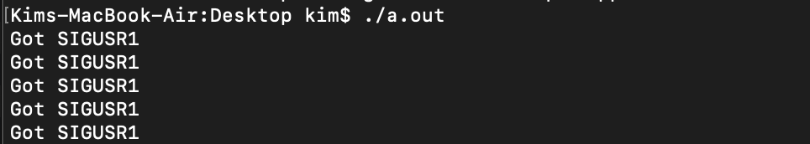

The time it took for the program to run was about 5 seconds because in the for loop, for each iteration there was a sleep(1) called which made the process rest for one second before continuing. The output was “Got SIGUSR1" five times. This is because the child process’ for loop’s kill() function is sending the SIGUSR1 signal to the current process. The SIGUSR1 signal is defined in signal_handler() which just simply prints out a string and a newline. Thus signal_handler() is called five times from the for loop in the child process.

1. What is the output with line 5 commented? How much time will it take now? [10 points]

Output:



The time it takes for the program to finish will still be five seconds because we are simple not sending a signal but the child process will still call sleep(1) five times in the for loop. Once the child process finishes, the program will simply terminate.

|  |
| --- |
| 1 void signal_handler **(**int signo**){**  2 printf **(**"Got SIGUSR1\n"**);**  3 **}**  4 int main **(){**  5  **signal (SIGUSR1, signal_handler);** //comment out for b)  6 int pid **=** fork **();**  7 **if** **(**pid **==** 0**){**// chilld process  8 **for** **(**int i**=**0**;** i**<**5**;** i**++){**  9 kill**(**getppid**(),** SIGUSR1**);**  10 sleep **(**1**);**  11 **}**  12 **}else{** // parent process  13 wait**(**0**);**  14 **}**  15**}** |

1. **[30 pts]** Write a wrapper class KernelSemaphore on top of POSIX kernel semaphore. See sem_overview(7) in man pages or linux.die.net to learn about kernel semaphores. Test your KernelSemaphore class by by setting the initial value to 0. Then write 2 programs – one waits for the semaphore and the other one releases (i.e., V()’) it. The header for the KernelSemaphore and the 2 programs in questions are provided in the below. You should make sure that the consumer program can only print out its prompt after the producer program has released the semaphore.

class KernelSemaphore{

    string name;

public:

    KernelSemaphore (string _name, int _init_value);

    void P();

    void V();

    ~KernelSemaphore ();

};

// producer.cpp (Run this first in a terminal)

int main (){

    cout << "This program will create the semaphore, initialize it to 0, ";

    cout << "then produce some data and finally V() the semaphore" << endl;

    KernelSemaphore ks ("/my_kernel_sema", 0);

    sleep (rand () % 10); // sleep a random amount of seconds

    ks.V();

}

// consumer.cpp (Run this second in another terminal)

int main (){

    KernelSemaphore ks ("/my_kernel_sema", 0);

    ks.P();

    cout << "I can tell the producer is done"<< endl;

}

